**LAB 01**

**QUESTION 1:**

**Write 1. Write a program that asks the user to enter today’s sales for five stores. The program should then**

**display a bar graph comparing each store’s sales. Create each bar in the bar graph by displaying**

**a row of asterisks. Each asterisk should represent $100 of sales.**

**Here is an example of the program’s output.**

**Enter today's sales for store 1: 1000 [Enter]**

**Enter today's sales for store 2: 1200 [Enter]**

**Enter today's sales for store 3: 1800 [Enter]**

**Enter today's sales for store 4: 800 [Enter]**

**Enter today's sales for store 5: 1900 [Enter]**

**SALES BAR CHART**

**(Each * = $100)**

**Store 1: \*\*\*\*\*\*\*\*\*\***

**Store 2: \*\*\*\*\*\*\*\*\*\*\*\***

**Store 3: \*\*\*\*\*\*\*\*\*\*\*\*\*\*\*\*\*\***

**Store 4: \*\*\*\*\*\*\*\***

**Store 5: \*\*\*\*\*\*\*\*\*\*\*\*\*\*\*\*\*\*\***

#include <iostream>

using namespace std;

void print(int arr[5])

{

for (int i = 0; i < 5; i++)

{

cout << "store " << i << " :";

for (int j = 0; j < arr[i] / 100; j++)

{

cout << "*";

}

cout << endl;

}

}

int main()

{

int arr[5];

for (int i = 0; i < 5; i++)

{

cout << "Enter today's sales for store " << i + 1 << ":";

cin >> arr[i];

}

print(arr);

}

**RESULT:**

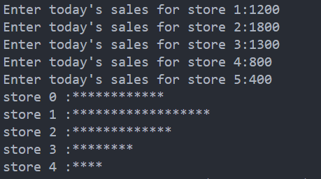

**QUESTION#2**

**Write a function named coin Toss that simulates the tossing of a coin. When you call the function, it should generate a random number in the range of 1 through 2. If the random number is 1, the function should display “heads.” If the random number is 2, the function should display “tails.” Demonstrate the function in a program that asks the user how many times the coin should be tossed and then simulates the tossing of the coin that number of times.**

**PROGRAM**:

#include <iostream>

#include <cstdlib>

#include <ctime>

using namespace std;

void coinToss(int *n*)

{

    srand((unsigned)time(NULL));

    for (int i = 0; i < *n*; i++)

    {

        int random = rand() % 2 + 1;

        if (random == 1)

        {

            cout << "head" << endl;

        }

        else

        {

            cout << "tail" << endl;

        }

    }

}

int main()

{

    int n;

    cout << "how many time you want to toss :";

    cin >> n;

    coinToss(n);

}

**RESULT**:

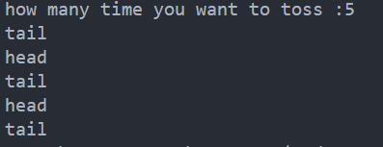

**QUESTION#3**

**Write a function that accepts three arguments: an array, the size of the array, and a number n. Assume that the array contains integers. The function should display all of the numbers in the array that are greater than the number n.**

#include <iostream>

using namespace std;

void print(int arr[], int n, int size)

{

    for (int i = 0; i < size; i++)

    {

        if (n < arr[i])

        {

            cout << arr[i] << endl;

        }

    }

}

int main()

{

    int size, n;

    cout << "enter number of integer for an array :";

    cin >> size;

    int arr[size];

    for (int i = 0; i < size; i++)

    {

        cout << "Enter " << i + 1 << " number ";

        cin >> arr[i];

        cout << endl;

    }

    cout << "enter number n ";

    cin >> n;

    print(arr, n, size);

}

**RESULT**:

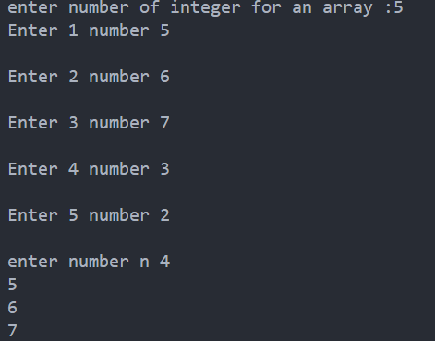

**QUESTION#4**

#include <iostream>

using namespace std;

void average(int data[3][5])

{

    int total[5] = {0};

    float average[5] = {0};

    for (int i = 0; i < 5; i++)

    {

        for (int j = 0; j < 3; j++)

        {

            total[i] += data[j][i];

        }

    }

    for (int i = 0; i < 5; i++)

    {

        average[i] = (float)total[i] / 3;

        cout << "average for day " << i + 1 << " :" << average[i] << endl;

    }

}

void least(int data[3][5])

{

    int min = data[0][0];

    for (int i = 0; i < 3; i++)

    {

        for (int j = 0; j < 5; j++)

        {

            if (min > data[i][j])

            {

                min = data[i][j];

            }

        }

    }

    cout << "least amount of food eaten by monkey during the week is :" << min << endl;

}

void max(int data[3][5])

{

    int max = data[0][0];

    for (int i = 0; i < 3; i++)

    {

        for (int j = 0; j < 5; j++)

        {

            if (max < data[i][j])

            {

                max = data[i][j];

            }

        }

    }

    cout << "max amount of food eaten by monkey during the week is :" << max << endl;

}

int main()

{

    int data[3][5] = {0};

    for (int i = 0; i < 3; i++)

    {

        cout << "Enter data for Monkey " << i + 1 << endl;

        for (int j = 0; j < 5; j++)

        {

            cout << "day " << j + 1 << " :";

            cin >> data[i][j];

        }

    }

    average(data);

    least(data);

    max(data);

}

**RESULT:**

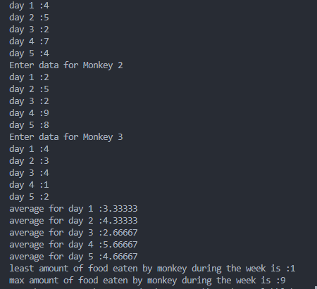

**QUESTION#5**

**The local Driver’s License Office has asked you to write a program that grades the written portion of the driver’s license exam. The exam has 20 multiple choice questions. Here are the**

**correct answers:**

**Your program should store the correct answers shown above in an array. It should ask the user to enter the student’s answers for each of the 20 questions, and the answers should be stored in another array. After the student’s answers have been entered, the program should display a message indicating whether the student passed or failed the exam. (A student must correctly answer 15 of the 20 questions to pass the exam.) It should then display the total number of correctly answered questions, the total number of incorrectly answered questions, and a list showing the question numbers of the incorrectly answered questions. Input Validation: Only accept the letters A, B, C, or D as answers.**

#include <iostream>

using namespace std;

void verify(char *arr*[], char *ans*[])

{

    int correct = 0;

    int incorrect = 0;

    for (int i = 0; i < 20; i++)

    {

        cout << "Enter Answer for option " << i + 1 << " from (A-D) :";

        cin >> *ans*[i];

        if (*ans*[i] < 'A' || *ans*[i] > 'D')

        {

            cout << "invald option" << endl;

            i--;

        }

        if (*ans*[i] == *arr*[i])

        {

            correct++;

        }

        else

        {

          incorrect++;

        }

    }

    cout << endl

         << "total correctly answered questions " << correct << endl;

    cout << "total correctly answered questions " << incorrect << endl;

    cout << "list of incorrectly answered questions are " << endl;

    for (int i = 0; i < 20; i++)

    {

        if (*arr*[i] != *ans*[i])

        {

            cout << i << endl;

        }

    }

}

int main()

{

    char arr[20] = {'A', 'B', 'A', 'C', 'D', 'A', 'C', 'C', 'B', 'B', 'D', 'A', 'B', 'C', 'B', 'D', 'C', 'D', 'D', 'B'};

    char ans[20];

    verify(arr, ans);

}

**RESULT**:

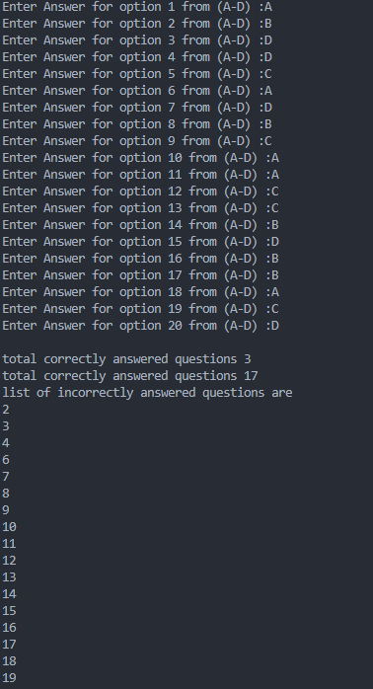

**QUESTION#6**

**You are tasked with developing a temperature monitoring system for a week (7 days). The system will:**

* **Calculate the average temperature for the week.**
* **Identify the highest and lowest temperature recorded.**
* **Determine the number of days with temperatures above 30°C and below 10°C.**

**Requirements:**

* **The program should accept daily temperature data for 7 days.**
* **The program should pass the temperature data to a function.**
* **The function should:**

**▪ Calculate the average temperature for the week.**

**▪ Determine the highest and lowest temperatures recorded.**

**▪ Count how many days had temperatures above 30°C and below 10°C.**

**▪ Display the report to the user.**

#include <iostream>

using namespace std;

void average(int arr[])

{

    int sum;

    for (int i = 0; i < 7; i++)

    {

        sum += arr[i];

    }

    float average = (float)sum / 5;

    cout << "average is : " << average << endl;

}

void highlow(int arr[])

{

    int max = arr[0];

    for (int i = 0; i < 7; i++)

    {

        if (max < arr[i])

        {

            max = arr[i];

        }

    }

    int min = arr[0];

    for (int i = 0; i < 7; i++)

    {

        if (min > arr[i])

        {

            min = arr[i];

        }

    }

    cout << "maximum temperature recorded is :" << max << endl;

    cout << "minimum temperature recorded is :" << min << endl;

}

void count(int arr[7])

{

    int cnt = 0;

    for (int i = 0; i < 7; i++)

    {

        if (arr[i] < 10 || arr[i] > 30)

        {

            cnt++;

        }

    }

    cout << "number of days greater than 30 and less than 10 are : " << cnt << endl;

}

int main()

{

    int arr[7];

    for (int i = 0; i < 7; i++)

    {

        cout << "enter temperature for day" << i + 1 << " : ";

        cin >> arr[i];

    }

    average(arr);

    highlow(arr);

    count(arr);

}

**RESULT**:

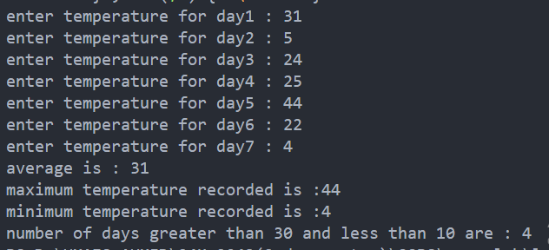

**QUESTION#7:**

**You are assigned the task of developing a GPA Calculator for FAST-NUCES. The program should accept the student's name and marks as input and display the corresponding grade and GPA points based on the university’s grading system."**

**Input:**

**Student Name: Noman**

**Marks: 74**

**Output:**

**Student Name: Noman**

**Grade: B**

**GPA: 3**

#include <iostream>

using namespace std;

void print(int *marks*)

{

    string grade;

    float gpa;

    if (marks >= 90)

    {

        grade = "A+";

        gpa = 4;

    }

    else if (marks >= 86)

    {

        grade = "A";

        gpa = 4;

    }

    else if (marks >= 82)

    {

        grade = "A-";

        gpa = 3.67;

    }

    else if (marks >= 78)

    {

        grade = "B+";

        gpa = 3.33;

    }

    else if (marks >= 74)

    {

        grade = "B";

        gpa = 3;

    }

    else if (marks >= 70)

    {

        grade = "B-";

        gpa = 2.67;

    }

    else if (marks >= 66)

    {

        grade = "C+";

        gpa = 2.33;

    }

    else if (marks >= 62)

    {

        grade = "C";

        gpa = 2;

    }

    else if (marks >= 58)

    {

        grade = "C-";

        gpa = 1.67;

    }

    else if (marks >= 54)

    {

        grade = "D+";

        gpa = 1.33;

    }

    else if (marks >= 50)

    {

        grade = "D";

        gpa = 1;

    }

    cout << "grade is :" << grade << endl;

    cout << "gpa is :" << gpa << endl;

}

int main()

{

    string name;

    int marks;

    cout << "Enter name :";

    cin >> name;

    cout << "Enter marks :";

    cin >> marks;

    print(marks);

}

**RESULT**:

